**Weather Trends Exploration**

1. Extracted data from database using SQL queries

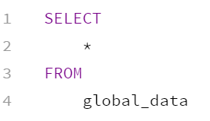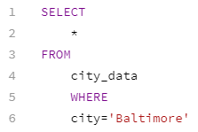

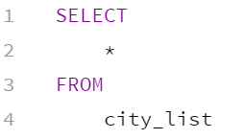

* 1. Downloaded data to .csv files for easier analysis and manipulation
  2. Filtered the city_data for my city (Baltimore)
  3. Consolidated data into a single Excel file

1. Organized data to have matching date ranges and to exclude incomplete data from Baltimore from 1743-1750.
2. Added columns to calculate a 10-year moving average for the temperatures of Baltimore and globally
   1. Calculated using the “Average” function in Excel where (=AVERAGE(G2:G11)) would return the 10 year average of the temperature average data situated in column G.
3. Created Line Chart
   1. Put the years on the horizontal axis and the temperature on the vertical axis, so that as you read the chart left to right, you’re easily seeing the chronological temperature trends.
   2. Set the interval at 10 years to give a cleaner look to the chart.
   3. Reduced the range of temperatures on the vertical axis to make trends more visible

Observations:

1. Both the global and local temperatures trend upwards from 1980-2010 and beyond
2. Both the global and local temperatures trend upwards from 1840-1940, with corresponding temperature dips around 1893 and 1911
3. From around 1810 to about 1820, both local and global temperatures dropped by over 1 degree Celsius before rising back up by 1830.
4. The local temperature trend shows a steep drop of nearly 2 degrees Celsius between the 1777 and 1787 moving averages. The averages quickly trend back up from 1787 to 1791. Upon examining the data, this seems to be caused by a flaw in the local temperature data, as the temperature average is missing for the year 1780. This outlier throws off the 10 Year moving averages, resulting in the dip in the trendline.